User Interface 1 (Login)

Login

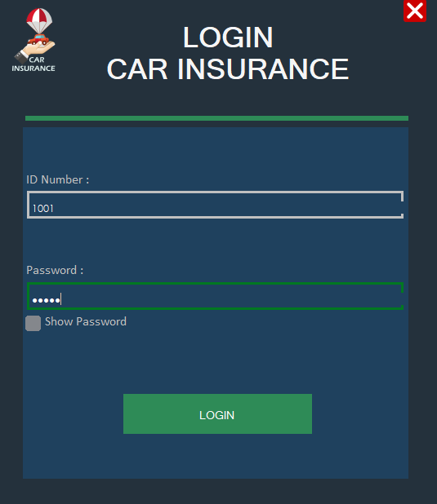

* If id number start with 1xxx it means user is admin.
* If id number start with 2xxx it means user is staff member.
* Data show include.

User Interface 2 (Admin Dashboard)

Admin (Tab 1)

* When you log as an admin this UI will show first.
* Also, admin can see his id on left up conner.
* When u first came in, you are in the first tab witch as ‘admin’
* In admin tab u can change your password, check old password, check settings, etc.
* Data update and Show include.

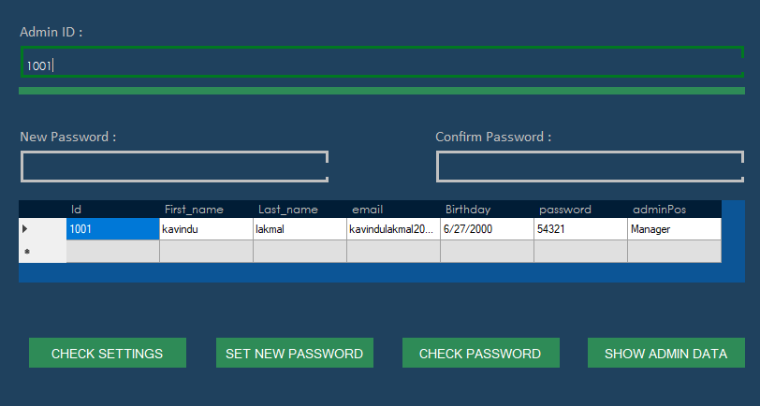

Staff (Tab 2)

* The admin can check about his own staff members.
* And remove or update.
* Data update, Show and delete include.

Customer (Tab 3)

* The admin can check about customer by their id.
* Also, can see the vehicle details.
* Data Show and delete include.

Register (Tab 4)

* Only admin can register staff members.
* Data insert include.

Check all (Tab 5)

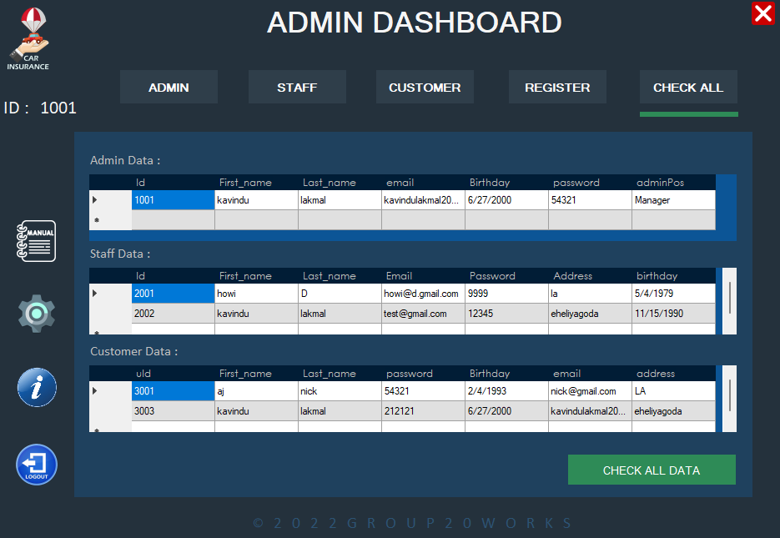

* Admin can see all the users of the system.
* Data show include.

User Interface 3 (Staff Dashboard)

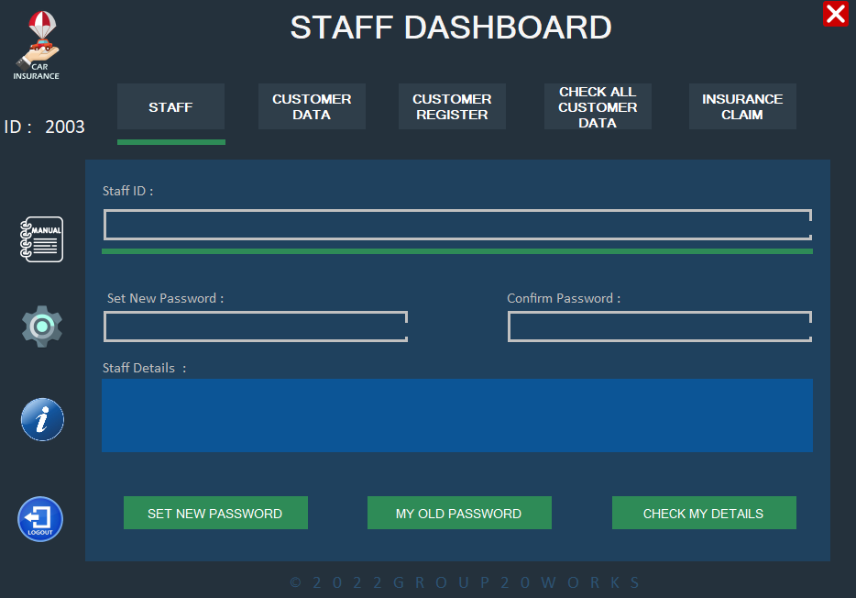Staff (Tab 1)

* Same as admin dashboard, the staff member can see his id left up conner.
* Staff member can change his password and check his all of data
* Data show and update include.

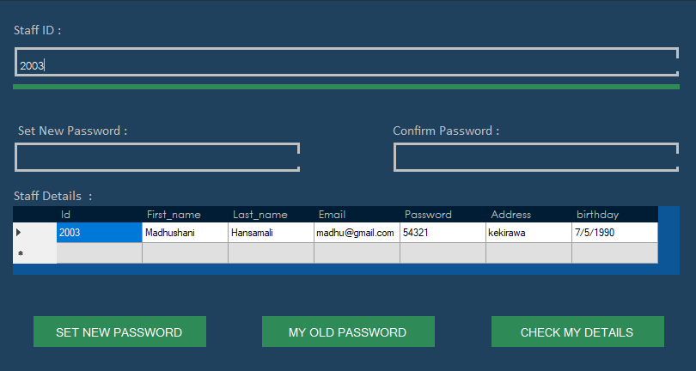

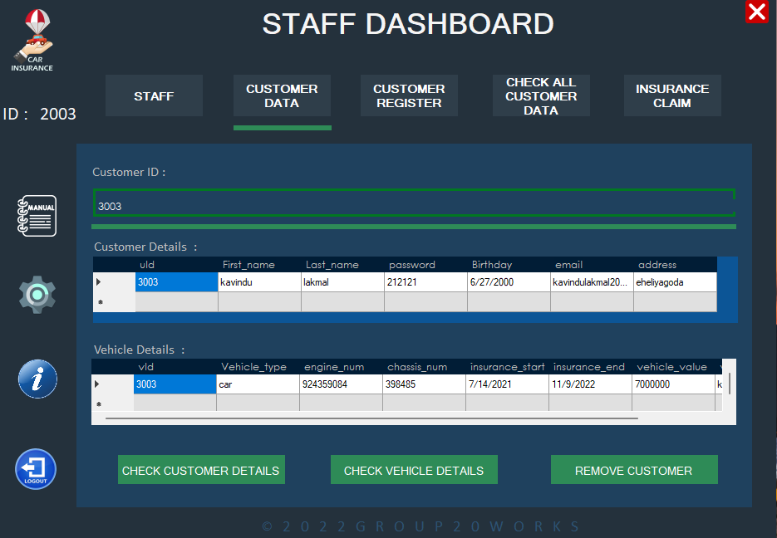Customer data (Tab 2)

* Staff can check about customer details and vehicle data.
* Data show include.

Customer register (Tab 3)

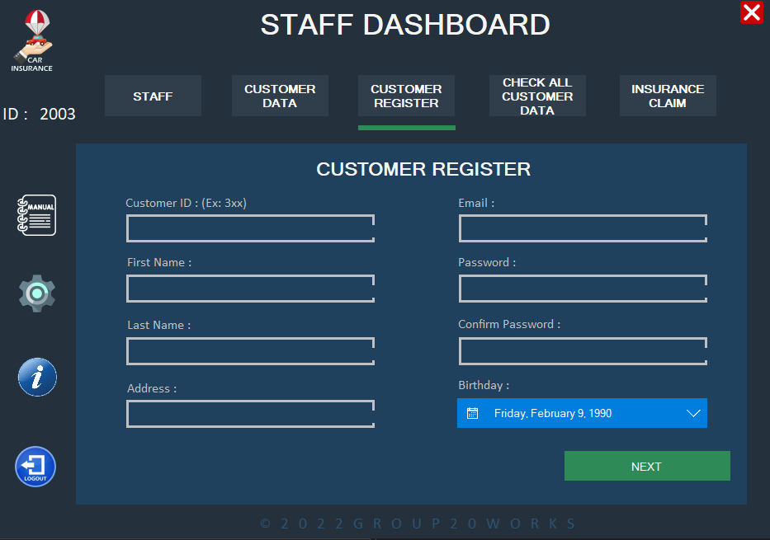

* Staff members can register customers from here.
* When we press next,

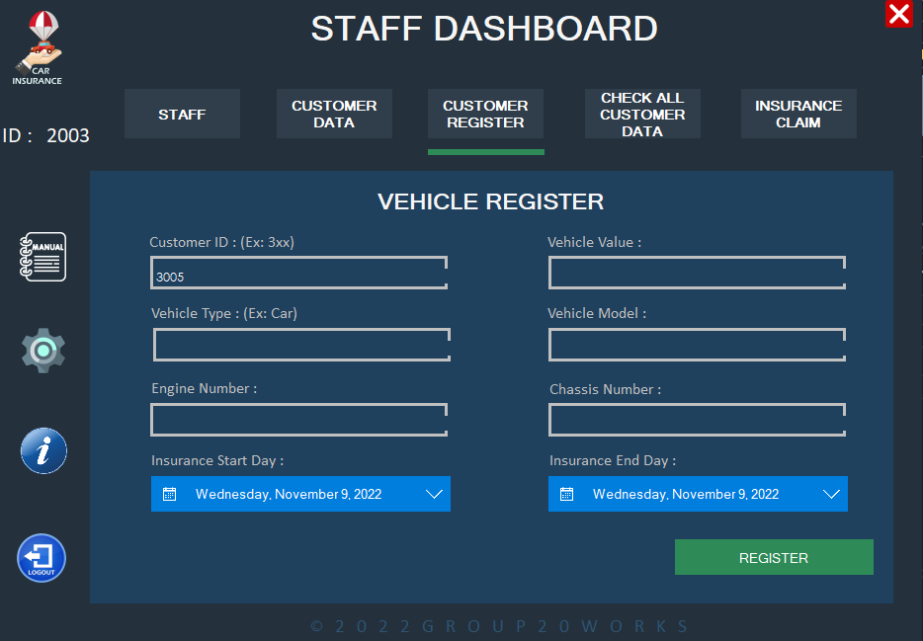

* Staff can register customer’s vehicle.
* Data Insert include.

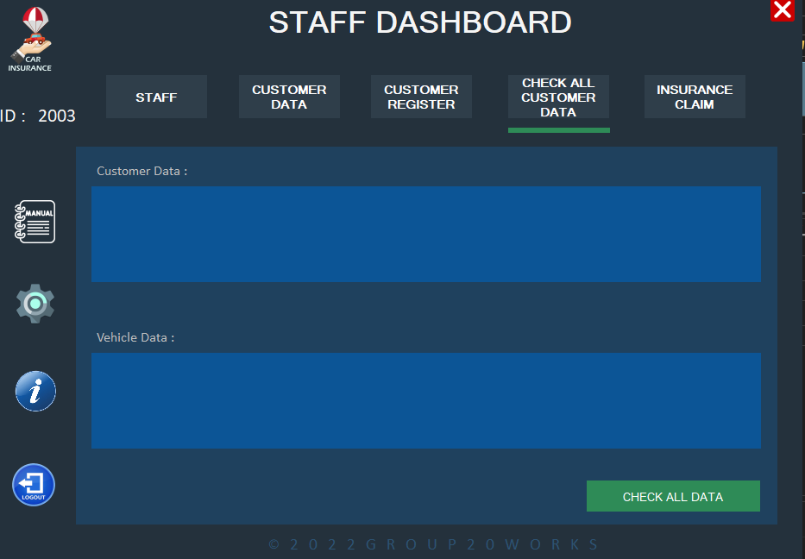Check all customer data (Tab 4)

* Staff can check about customers vehicle details and customer details.
* Data show include.

Insurance claim (Tab 5)

* Staff can find user by name and then get his id.
* Then entering the customer id to last text box then press “next”.
* If want can delete old claim report from here.

User Interface 4 (Claim Report)

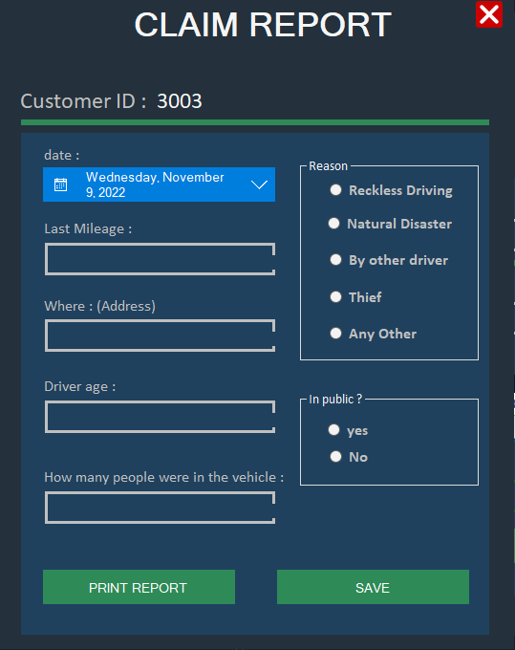

* When came into claim report staff can see customer id in top left conner.
* Then fill the report by using customer information
* After that staff can save or print the report.

Dashboard tools

Developer contact

Logout from the system

Settings

Manual for new users

User Interface 5 (Manual)

* System information for new user

User Interface 6 (Settings)

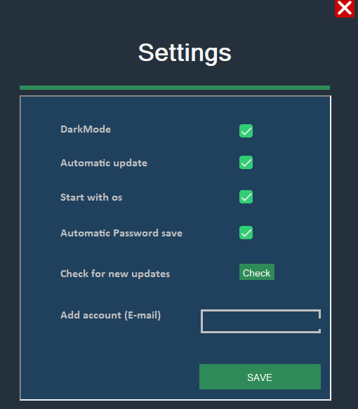

* User can change system settings from here (Still in developer level).
* When user press the check new updates this will opens our project file in GitHub.
* Data insert include.

User Interface 7 (Developer Support)

* User can contact developers by click this link.
* This links will open’s developers GitHub accounts.